**Контрольная работа за 1 полугодие**

**7 класс (УМК «Starlight») V- 1**

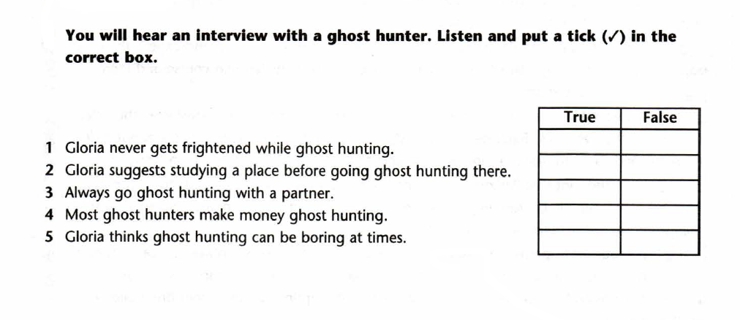**TASK 1. LISTENING**

**TASK 2. READING**

**Read the text and mark the statements TRUE (T), FALSE (F) or NOT STATED (NS).**

I’ve always been a big fan of fairy tales and castles. So, last year, while travelling in Ireland with mum we stayed in a real medieval castle. We planned to stay for just one night. But the following morning I woke up with a terrible headache. I couldn’t swallow and my throat was sore, and the temperature was high. There was no thinking about going anywhere. So, mum asked the receptionist to call the doctor.

Ye arrived and diagnosed me with flu. And this meant at least a week of staying in bed. To be honest, I felt really bad. The doctor prescribed some pills, injections and mixtures. He said my condition was really serious. He promised to send a nurse every day to check me. I felt sorry because it was summer and the weather was beautiful. Anyway, there was no other way out but take medicines and sleep and wait.

the next evening my mother was sitting at my bed side, I was half asleep, so I don’t remember everything, but my mother does. A nurse came in to check my temperature. Mum noticed that this nurse was odd looking. She was wearing this old-fashioned 1960s-style nurse clothing. But she had a kind face and a nice smile. She brought a new mixture and gave me just a small teaspoonful. She talked to her and said I would soon recover.

I woke up the following morning feeling much better. Mum phoned the doctor and said “Kate is feeling much better. Thanks for sending that lovely lady with a new medicine to us yesterday.” “But I haven’t sent anyone, Mrs. Lawrence,” he answered.

Who was she then? I’m still wondering. Really weird, don’t think so?

1. Kate wanted to stay in a haunted castle while travelling. _____________
2. Kate fell seriously ill during the trip in Ireland. ______________
3. Kate was afraid of injections and disliked pills. ____________
4. the doctor left a nurse to look after Kate. _____________
5. Kate caught flu in cold winter weather. ____________
6. The nurse who visited Kate looked really strange. _________
7. The medicine which the nurse brought helped Kate. ________

**TASK 3. VOCABULARY & GRAMMAR**

1. **Fill the right word.**

|  |  |  |  |  |  |  |  |  |  |
| --- | --- | --- | --- | --- | --- | --- | --- | --- | --- |
| ***ear*** | ***duty*** | ***solve*** | ***parachutes*** | ***shared*** | ***curious*** | ***earn*** | ***apply*** | ***felt*** | ***rose*** |

1.       Can you ........ this problem?

2.       Students often work part-time to ........ money.

3.       A smokejumper ........ out of an aeroplane into a fire zone.

4.       It’s a lifeguard’s ....... to rescue people in danger of drowning.

5.       Joe wants to ........ for the administrative job.

6.       Jake is very ........ and likes to find out about everything.

7.       Thomas ........ seasick as the waves rocked the boat from side to side.

8.       She ........ her experience of working in the music business with her fans.

9.       Before the curtain ........ the actors took their place on the stage.

10.  She was very talented and could play the violin by ........ .

1. **Choose the correct item.**
2. How often (*you go / are you going / do you go*) to the gym?
3. I’m afraid we got (*off / in / on*) the wrong bus.
4. Our diving instructor doesn’t let us (*to use / using / use*) his equipment.
5. Is Ann (*looks / looking / look*) for a new job?
6. I don’t mind (*working / to work / work*) in an office, but I’d rather work outdoors.
7. They *(had been saving / were saving / use to save*) some money before they went on holidays.
8. Max (*played / was playing / had been playing*) the guitar while Ann was talking on the phone.
9. I called you an hour ago, but I couldn’t get (*on / away / through*).
10. This soup (*taste / is tasting / tastes*) fantastic.
11. They escaped to Australia before war broke (*down / out / in*) in 1939.
12. Sandra is looking forward (*to go / go / to going*) on holiday next week.
13. He was tired because he (*was working / had working / had been working*) in the garden since morning.
14. We (*take / had taken / took*) pictures of the artefacts yesterday.
15. He was afraid because he (*saw / had seen / see*) a ghost.
16. I (*was watching / had been watching / watched*) TV for an hour when I remembered I had forgotten to call my friend.
17. **Write the correct form of the capitalized words.**
18. John is a popular ______________. He has got a lot of followers. (BLOG)
19. Rowan Atkinson is a famous British___________ (COMEDY).
20. If you want to watch a music ___________ take a look at Chenese Opera (PERFORM).
21. The Eiffel Tower is the most popular ____________ (ATTRACT) in Europe.

**Контрольная работа за 1 полугодие**

**7 класс (УМК «Starlight») V-2**

**TASK 1. LISTENING**

**TASK 2. READING**

**Read the text and mark the statements TRUE (T), FALSE (F) or NOT STATED (NS).**

I’ve always been a big fan of fairy tales and castles. So, last year, while travelling in Ireland with mum we stayed in a real medieval castle. We planned to stay for just one night. But the following morning I woke up with a terrible headache. I couldn’t swallow and my throat was sore, and the temperature was high. There was no thinking about going anywhere. So, mum asked the receptionist to call the doctor.

Ye arrived and diagnosed me with flu. And this meant at least a week of staying in bed. To be honest, I felt really bad. The doctor prescribed some pills, injections and mixtures. He said my condition was really serious. He promised to send a nurse every day to check me. I felt sorry because it was summer and the weather was beautiful. Anyway, there was no other way out but take medicines and sleep and wait.

the next evening my mother was sitting at my bed side, I was half asleep, so I don’t remember everything, but my mother does. A nurse came in to check my temperature. Mum noticed that this nurse was odd looking. She was wearing this old-fashioned 1960s-style nurse clothing. But she had a kind face and a nice smile. She brought a new mixture and gave me just a small teaspoonful. She talked to her and said I would soon recover.

I woke up the following morning feeling much better. Mum phoned the doctor and said “Kate is feeling much better. Thanks for sending that lovely lady with a new medicine to us yesterday.” “But I haven’t sent anyone, Mrs. Lawrence,” he answered.

Who was she then? I’m still wondering. Really weird, don’t think so?

1. Kate wanted to stay in a haunted castle while travelling. _____________
2. Kate fell seriously ill during the trip in Ireland. ______________
3. Kate was afraid of injections and disliked pills. ____________
4. the doctor left a nurse to look after Kate. _____________
5. Kate caught flu in cold winter weather. ____________
6. The nurse who visited Kate looked really strange. _________
7. The medicine which the nurse brought helped Kate. ________

**TASK 3. VOCABULARY & GRAMMAR**

1. **Fill the right word.**

|  |  |  |  |  |  |  |  |  |  |
| --- | --- | --- | --- | --- | --- | --- | --- | --- | --- |
| ***engine*** | ***vacancies*** | ***ear*** | ***champion*** | ***caught*** | ***take*** | ***biting*** | ***lighting*** | ***attention*** | ***carried*** |

1.       Sara Campbell is a world ........ free diver.

2.       Molly wants to ........ up UFO hunting as a hobby.

3.       Are there any job ........ in the newspaper?

4.       Joe doesn’t like mosquitoes ........ him.

5.       They got ........ in bad weather while on holiday.

6.       She was very talented and could play the violin by ........ .

7.       They use lanterns for ........ at the Chinese opera.

8.        The singer’s performance grabbed the ........ of the world.

9.        Google became a popular search ........ on the Net.

10.    The street performer’s voice ........ out for miles.

1. **Choose the correct item.**
2. How often (*you go / are you going / do you go*) to the gym?
3. I’m afraid we got (*off / in / on*) the wrong bus.
4. Our diving instructor doesn’t let us (*to use / using / use*) his equipment.
5. Is Ann (*looks / looking / look*) for a new job?
6. Mary can’t stand (*to take / taking / take*) the bus to work every morning.
7. They (*had been saving / were saving / use to save*) some money before they went on holidays.
8. They (*was driving / were driving / had driven*) when they got a flat tyre.
9. I called you an hour ago, but I couldn’t get (*on / away / through*).
10. This music (*sound / sounds / is sounding*) good.
11. They escaped to Australia before war broke (*down / out / in*) in 1939.
12. Sandra is looking forward (*to go / go / to going*) on holiday next week.
13. They were very tired because they (*were painting / painted / had been painting*) their room all day.
14. We (*take / had taken / took*) pictures of the artefacts yesterday.
15. He was afraid because he (*saw / had seen / see*) a ghost.
16. I (*was watching / had been watching / watched*) TV for an hour when I remembered I had forgotten to call my friend.
17. **Write the correct form of the capitalized words.**
18. If you want to watch a music ___________ take a look at Chenese Opera (PERFORM).
19. John is a popular ______________. He has got a lot of followers. (BLOG)
20. The Eiffel Tower is the most popular ____________ (ATTRACT) in Europe.
21. Rowan Atkinson is a famous British___________ (COMEDY).